Problems from Crux MathemAttic, due December 15, 2025

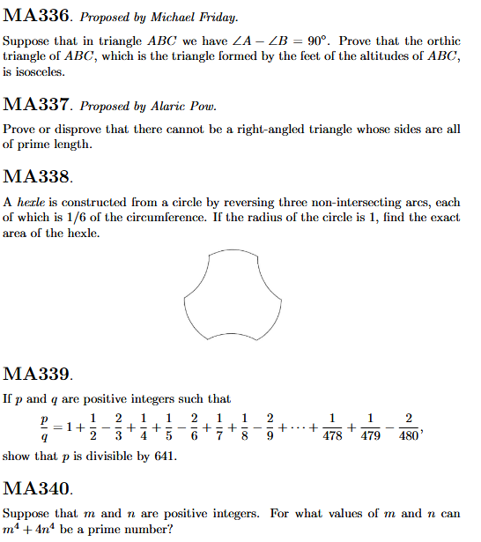

Problems from Crux Olympiad Corner, due December 15, 2025

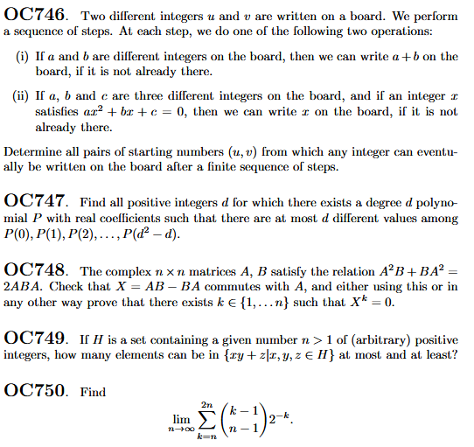

Problems from Crux Mathematicorum, due December 15, 2025

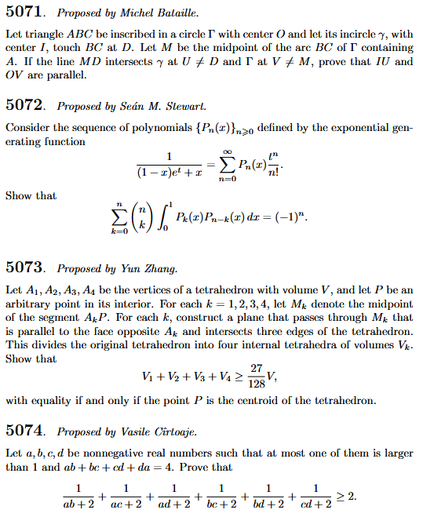

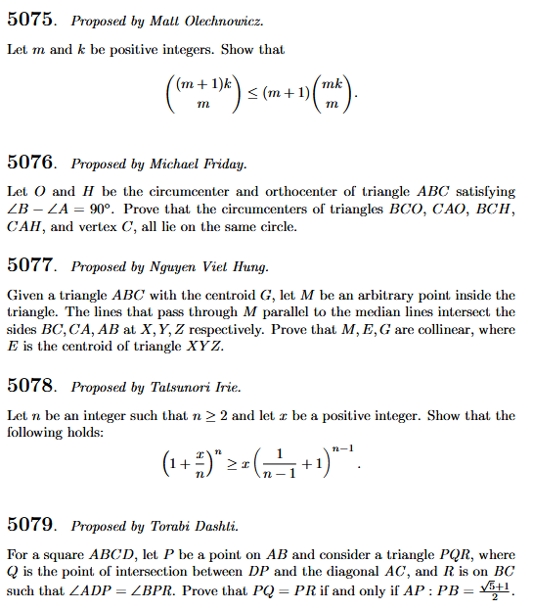
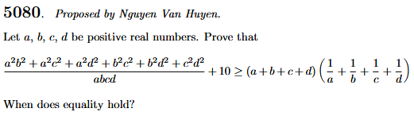

Problems from the American Mathematical Monthly due December 31, 2025

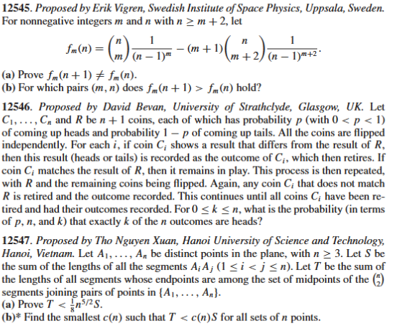
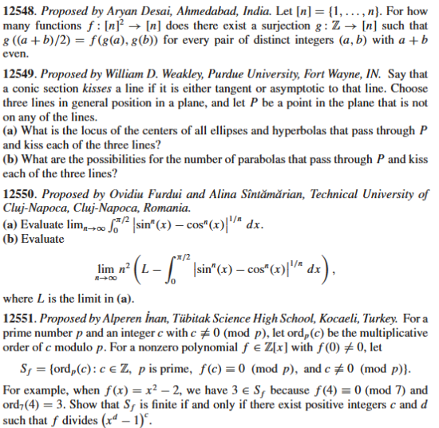

Problems from Crux MathemAttic, due January 15, 2026

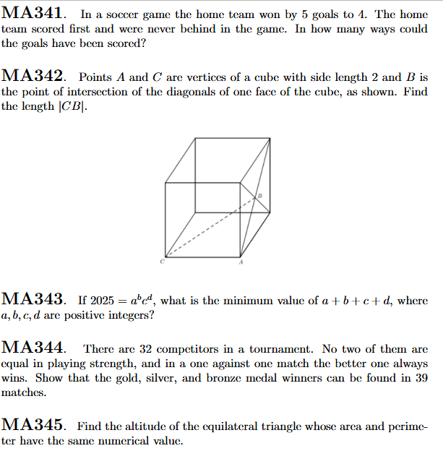

Problems from Crux Olympiad Corner, due January 15, 2026

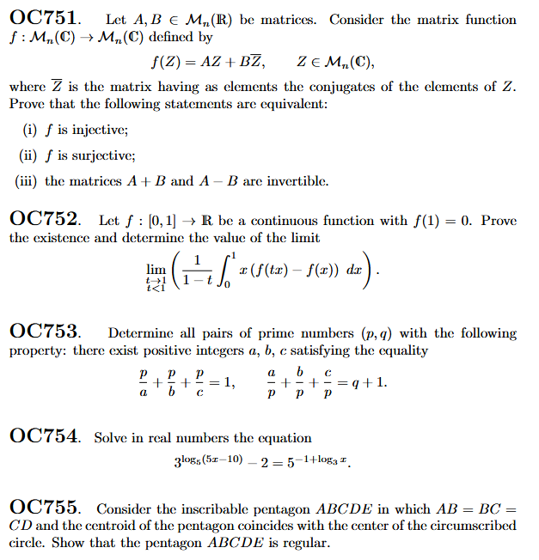

Problems from Crux Mathematicorum, due January 15, 2026

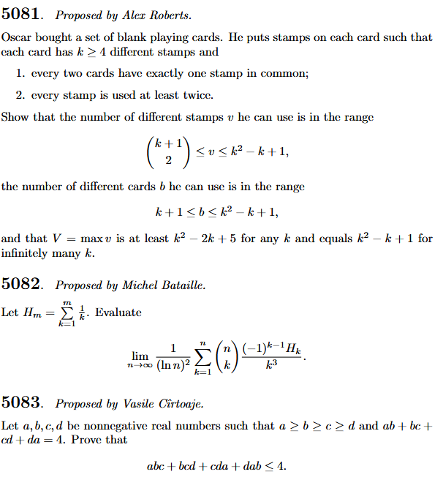
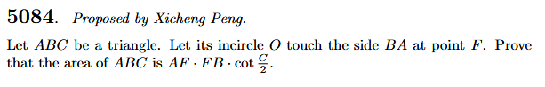

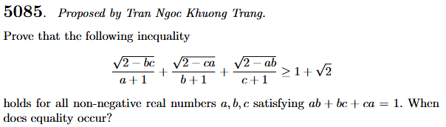

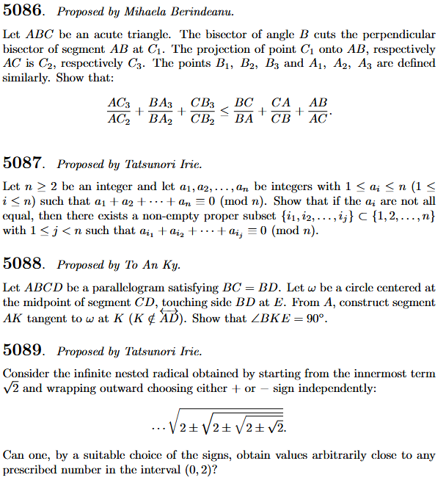

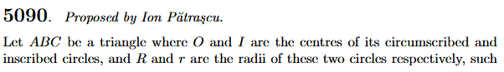
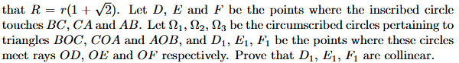

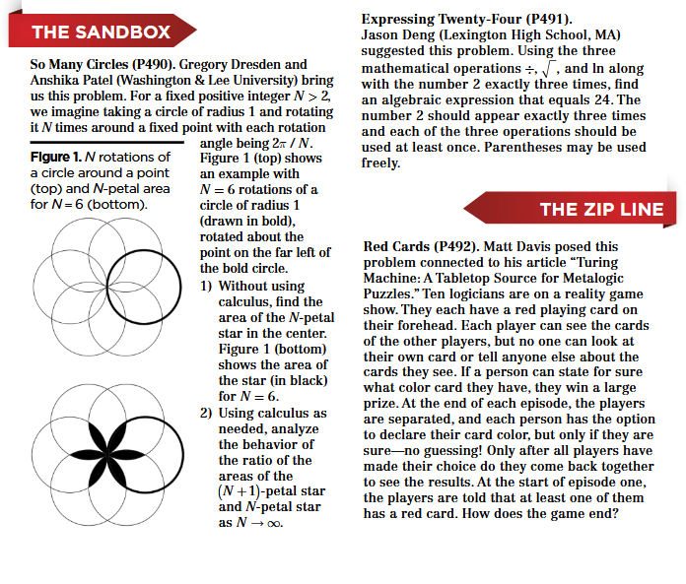
Problems from Math Horizons, due January 15, 2026

